**RUCHARDTS TUBE**

SPECIFIC HEAT RATIO OF GASES

General Object: To measure the ratio of the specific heat at constant pressure to the specific  
heat at constant volume for monatomic and diatomic gases.

General Theory: In an ideal gas the molecules are pictured as hard elastic spheres; that is,  
there are no forces between the molecules except during collisions. This means  
there is no internal potential energy and the internal energy of an ideal gas is  
entirely kinetic. Simple kinetic theory (CH. 23-4, "Physics' by Halliday and  
Resnick) shows that the average kinetic energy per molecule is  kT, where T is  
the absolute temperature and k is Boltzmann's constant. The total internal  
energy U of an ideal gas containing N molecules is



and, writing Nok = R, where No is Avogadro's constant and R is the Universal  
Gas Constant,

, (1)

where the quantity of gas is expressed as μ. moles.

This prediction of kinetic theory says that *the internal energy per mole of an ideal gas is  
proportional to the Kelvin temperature and depends only on the temperature,* being  
independent of pressure and volume. From this result information may be obtained on the  
specific heats of an ideal gas.

The specific heat of a substance is the heat required per unit mass to cause unit temperature  
change. A convenient unit of mass is the mole. The corresponding specific heat is called the  
molar heat capacity and is represented by C. Only two varieties of molar heat capacity are  
important for gases, namely, that at constant volume, Cv, and that at constant pressure, Cp .

An equation relating these two quantities can be derived by considering constant-volume and  
constant-pressure processes which both change the temperature by the *same* small amount ΔT.

The first law of thermodynamics may be stated as

ΔQ = ΔU + ΔW, (2)

where ΔQ is the quantity of heat energy *entering* any system, ΔU is the *increase* in internal  
energy and ΔW is the work done *by* the system. For a small change in the volume it can be  
shown (Ch. 22-6, 'Physics' by Halliday and Reskick) that ΔW = pΔV, so for a constant-volume  
process ΔW = 0 and ΔQ = ΔU. Also, by definition of Cv, ΔQ = μ Cv ΔT, thus

ΔU = μ Cv ΔT (3)

Now suppose the temperature of the system is changed by the *same* amount ΔT from the  
*same* initial state by a constant-pressure process.

By definition of Cp, ΔQ = μCp ΔT and this time ΔW = pΔV ≠ 0. Also, since both processes

involve the same temperature change they have the same change in internal energy, μCv ΔT  
Thus for the constant-pressure process the first law yields

μCXpΔT = μCvΔT + pΔV (4)

Application of the Ideal Gas Equation to the constant-pressure process yields

pΔV = μRΔT (5)

Combining equations (4) and (5) gives

Cp - Cv = R (6)

If Cv can be found then equation (6) will give Cp . Now Cv *can* be found using equation (1)



This result is good for monatomic gases. However, it is in serious disagreement with values  
obtained for diatomic and polyatomic gases. This means that equation (1) is not generally  
correct and the molecular model must be change if kinetic theory is to be useful as an  
approximation to the behaviour of real gases.

For diatomic and polyatomic gases the molecules are pictures, not as rigid particles, but as  
objects with international structure. These molecules can rotate and vibrate as well as move  
with translational motion. In collisions, the rotational and vibrational modes of motion can  
be excited and this will contribute to the internal energy of the gas. This model allows  
modification of the kinetic theory formula for the internal energy of a gas.

In general then the total internal energy of a gas will consist of kinetic energy of translation,

with terms like ; of rotational kinetic energy, with terms like ; of kinetic energy of

vibration of the atoms in a molecule, with terms like (where m is the 'reduced mass'),

and of potential energy of vibration of the atoms in a molecule, with terms like 

From study of the statistical behaviour of a large number of molecules obeying Newtonian

mechanics, it can be shown that all of these terms have the same average value, and this

value depends only on the temperature. In other words, the available energy distributes itself

equally among each of the independent ways in which the molecules can absorb energy. This

theorem is called the *equipartition of energy* and each independent mode of absorption of

energy is called a *degree of freedom.*

For *monatomic gases* the molecules have only translational motion and so three degrees of  
freedom. Each mode will contribute . Thus the specific heat ratio is



For a *diatomic gas* each molecule can be thought of as a dumbbell, such a molecule will have  
two rotational degrees of freedom. (The energy of rotation about its own axis may be

ignored.) It will also have two more degrees of freedom from its kinetic and potential energies of vibration.

This would result in a value for Cv equal to R.

However, experiment has shown (see Fig. 1) that

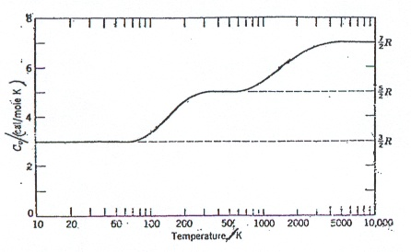

**Fig.** I**:** Variation of the molar heat Cr of hydrogen with temperature.  
Note that T is drawn on a logarithmic scale.

the value of Cv is not independent of temperature. The behaviour of Cv with temperature as

shown in Fig. 1 is explained by the idea that at low temperatures diatomic molecules have

translational energy only and cannot rotate or vibrate, since only the ground state of the

vibration-rotation levels is populated. As the temperature rises upper levels become

populated and rotation becomes possible so that the diatomic molecule acts like the dumbell

model. At higher temperatures the collisions between molecules cause the atoms to vibrate

also. Different gases may show these effects at different temperatures but a number behave in

a fairly similar way at room temperature, e.g. hydrogen, oxygen and nitrogen have values of

 at 20°C**.**

This gives 

Reference : CH.23 Physics" by Halliday and Resnick.

**RUCHARDTS TUBE**

Object: To determine the specific heat ratio for air and for helium.

**Theory:** Consider a small displacement y of a close-fitting piston of mass M from its equilibrium position in a Tube closed at both ends. This will cause a change in the volume of gas above or below the piston,which is very small compared with the equilibrium volume v, and which therefore can be denoted

by dV, where

dV = y.A (7)

( This is the change in volume of the gas on one side only )

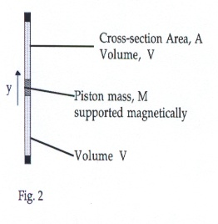

There will be a corresponding change in pressure which is small compared with the equilibrium pressure P and which therefore can be denoted by p.

Neglecting friction the resultant restoring force F acting on the piston is equal to A.p or

2.p = F/A (8)  
(The factor 2 is due to the fact that there are two volumes - one on each side)

Now, as the piston oscillates fairly rapidly, the variations of p and V are adiabatic (i.e. ΔQ = 0).

Since the variations are also quite small the states through which the gas passes can be

considered to be approximately states of equilibrium. We may therefore assume that the

changes of p and V represent an approximately adiabatic process, and we may write

*=* a constant, (for proof see Halliday and Resnick)

and



giving

 (9)

Using expressions (7) and (8) to substitute in equation (9) gives

 (10)

This equation expresses the fact that the restoring force is directly proportional to the

displacement and is in the opposite direction. This is precisely the condition for SIMPLE

HARMONIC MOTION.

It may be written



where

**

and

f  (11)

Now if the piston is FORCED to oscillate and frictional damping is small then the amplitude

of the motion will be at maximum when the applied frequency is equal to the 'natural'

frequency of the system i.e. the frequency given by equation (11), the unforced frequency.

This is called the resonance condition.

( Equation (11) may be written as f=, where K is the so-called ‘force-constant’ of the gas )

Measurements of the resonant frequency for gas pressure p, and A, M and V allow the specific  
heat ratio  to be determined.

For a general expression the restoring forces due to the magnetic support and friction may be  
allowed for by writing the total restoring force as (Ks + K )y, where Ks is the total force constant  
for the support and friction. This leads to a resonant frequency given by



Giving

 (12)

**Reference:** B.M.Flowers and E.Mendoza: Properties of Matter, (1970),Ch.5

Apparatus Notes : **(1) Fig. 3 shows a schematic diagram of the apparatus.**

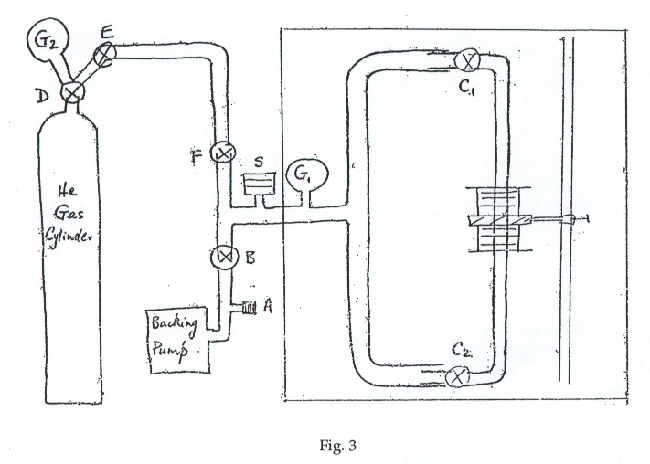

1. **A small permanent magnet is attached to the aluminium piston so that the piston may be held in its equilibrium Position at the centre of the glass tube by an external permanent magnet in the form of a thick single-turn coil.**
2. **On the same support is held a small solenoid to which may be applied an alternating  
   voltage to produce forced oscillations of the piston.**
3. **Valves ′C1′ and ′C2′ allow a known volume of gas ,V, to be enclosed in the experimental**

**Tube**

# Precautions

**(1) When the backing pump is switched off valve *'A'* must be opened to release the  
vacuum otherwise the pump oil will be sucked up into the vacuum system!**

**In all cases both of the valves (C1and C2)at the ends of the tube must be open before any**

**attempt is made to change the pressure of the gas. If this is not adhered to then the**

**piston may be driven up the tube with some force and may damage the glass tube.**

**A student who is filling the system with helium for the first time should do so under**

**the supervision of a demonstrator. The safety release valve 'S' may be weighted to**

**allow pressures up to either 1 atmosphere or 2 atmospheres to be used.**

## The copper tube above valve F to the helium cylinder should never be strongly

**Evacuated otherwise the guage G3 may be damaged**

(5) **Directly after each resonance frequency has been recorded increase the frequency away**

**from its resonance value until the piston stops oscillating otherwise, when the pressure**

**is being changed, the amplitude of the oscillations may be made to increase so much**

**that the piston *'escapes'* from the restoring permanent magnetic field. If the piston**

**does drop down please consult a demonstrator.**

### Supplied Data

(I) The volume of gas enclosed when the valves C1 and C2 are closed is V = (5.22 ± 0.02) x  
 10-5 m3.

(ii) The mass of the piston is M = (0.6528 ± 0.0001) x 10-2 kg.

(iii) The internal cross-section area of the precision glass tube is A *=* (1.54 ±0.01) x 10-4 m2.

1. Conversion factor : 1 torr = 133.3 Nm-2.

# Footnote on "Pressure"

"Absolute Pressure" : Pressure measured with respect to zero pressure.  
"Gauge Pressure" : Pressure measured with respect to that of the atmosphere.

Hence the absolute pressure corresponding to a measured gauge pressure will depend upon  
the exact atmospheric pressure at the time of measurement. There are many units which  
may be used as units of pressure :-

The SI unit for pressure is the "pascal" - symbol "Pa"

Pa = m-1 kg s-2 = Jm-3 = Nm2Conversion Factors

1 torr, (= ImmHg) = 133.3 Nm-2 = 133.3 Pa

1 bar = 1000 millibar = 10s Nm-2 = 105 Pa

1 millibar = 100 Nm-2 = 100 Pa

1 bar = 14.50 Ib in2 = 106 dynes cm-2 = 29.53 in.

1 bar *=* 0.9869 atmospheres.

1 atmosphere = 1.013 x 105 Nm-2 = 1.013 x 105 Pa (Definition of 1 atmosphere)

1 atmosphere = 760 torr

(N.B. the 'atmosphere' is a standard unit, but the actual atmospheric pressure varies daily.)

Procedure:

*To find *

(1) Remind yourself of the precautionary notes.

(2) You should find the system with valve A open.

Close F and check that the applied frequency is well away from resonance.  
Open C1and C2.  
Open B.

Open A, if it is not already open. The tube will now be filled with air at atmospheric  
pressure as indicated by the dial gauge G1.

Close A.

Close B.

Close C1 and C2

The tube is now ready for taking a reading of the resonance frequency, *fo,* at atmospheric  
pressure.

(3) Use the counter for accurate measurements of the frequency. If in doubt about its use

consult a demonstrator.

1. Measure fo and determine the value of γ for air at atmospheric pressure.

(5) To get a better determination of γ obtain fo for several different air-pressure values,  
 obtained by evacuating the air from the system in controlled stages.

**Procedure**

To find 

1. First the system has to be evacuated. Check that the applied frequency is well away

from resonance. With F closed open C1 and C2, then B, and evacuate the experimental  
 tube. The pump should be allowed to evacuate this region for at least 5 minutes.

1. Under the supervision of a demonstrator the following procedure should be adopted to

fill the experimental tube with helium.

Weight the safety valve S for 1 atmosphere or 2 atmospheres as required (usually ready).

Open valve D on the helium cylinder until a low reading is indicated on gauge G2.

This indicates the pressure between valves D and E.

Open valve E.

Now keeping C1 and C2 open, close B.

Valve F may now be very slowly opened to allow helium gas into the experimental

tube to any desired pressure indicated by the dial gauge G1

You should find it convenient to start with a high pressure, e.g. 1 atm (~ 14 psi) above

atmospheric pressure. Then *shut valves* F, E and D. To subsequently reduce the

pressure in the system, open valve B to pump out some of the gas.

(7) When G1 indicates any desired pressure close C1 and C2 and find this value of the resonant frequency.

1. Using an appropriate graph and the data supplied find . Compare your value withthe value

predicted by theory.

1. Consult a demonstrator to obtain a cylinder of nitrogen, replace the He cylinder, and

determine . Compare your value with the value predicted by theory.

1. Compare the ratio of your two experimental values of γ with the ratio of the two

theoretical values.

1. Refer to the paper by Clark & Katz and consider the effect of corrections to the theory.

Simple Cb / Cn resonance apparatus suitable for the physics teaching laboratory

D.G. Smith, Am.J.Phys. 47, ( July,1979).

A.L. Clarkand and L.Katz, Can.J.Res A18,23,(1940).

E. Richards,Phys, Zeit.30,58,(1929).

